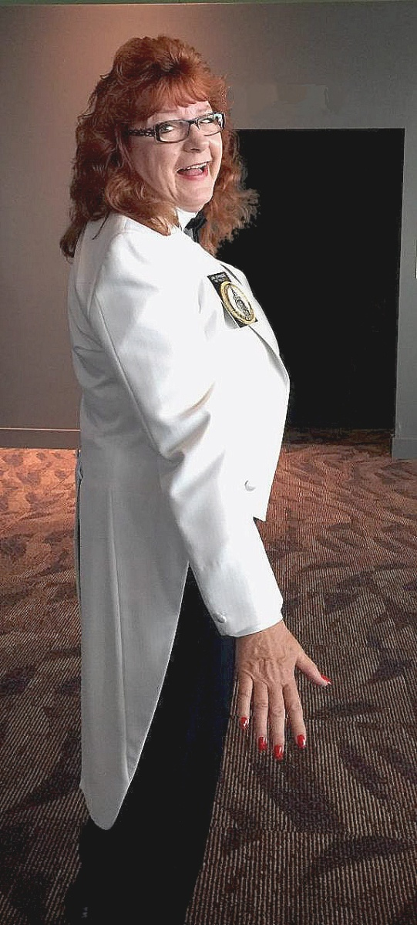
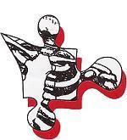
COURSE DATES
December 6th – 10th, 2027 | Monday to Friday
(unless not testing, see course description)
Time: 8:00 am – 5:00 pm
COURSE LOCATION
Pensacola, FL – Exact location TBD
Contact Forensic Pieces
directly for further details
COURSE HOST
Forensic Pieces, Inc.
Crystal Merrell | Phone: (850) 332-0141
Email: info@forensicpieces.com
COST: $465**
**COURSE TUITION OF $465 DOES NOT INCLUDE THE IAI EXAM
FEE. PLEASE CALL THEM FOR DETAILS ON HOW TO APPLY/PAY
OR VISIT: https://www.theiai.org/crime_scene.php

PLEASE MAKE CHECKS PAYABLE TO: FORENSIC PIECES, INC.
TIN# 900496490. CREDIT CARD PAYMENTS ARE ALSO ACCEPTED. PLEASE NOTE: A 3.5% NONREFUNDABLE CARD PROCESSING FEE IS ADDED TO THE COURSE TOTAL IF A CREDIT CARD IS USED. PLEASE MAIL CHECKS TO FORENSIC PIECES (CONTACT INFO BELOW).
In Honor of Our Beloved Founder
of Forensic Pieces Inc.,
Jan Johnson, CSCSA
We commit to you the same techniques, structure, and integrity that our fearless leader Jan Johnson carried with her to every scene, every training, every conference, every time. It will be our constant goal to strive, meet, and exceed the extremely high standards set by the one who led thousands all over the world to success in the areas of Crime Scene Investigation, Bloodstain Pattern Analysis, Shooting Reconstruction, Crime Scene Reconstruction, and so much more.
Each instructor and training will reflect the legacy Jan wanted for her company and the forensic community. We appreciate all the continued support as we forge our new path forward. As Jan Johnson would always say: Full Speed Ahead!
-PLEASE KEEP IN MIND, OUR DERIVED MOCK
TEST QUESTIONS AND ANSWERS WILL NOT
BE PASSED OUT PRIOR TO CLASS.

- IT IS MOST ADVANTAGEOUS TO HIGHLIGHT
BOOKS PRIOR TO CLASS. FAILURE TO DO SO
WILL SLOW DOWN & DIMINISH THE QUALITY
OF THE TRAINING.

REGISTER TODAY!!
Call, Email, or Register Online

Phone: (850) 332-0141
Email: info@forensicpieces.com
Web: www.forensicpieces.com

Check out the second page of this brochure for Instructor Bio, Course Description and Topics, What to Bring, & Recommended Lodging.

Registration for the Forensic Pieces of
IAI Crime Scene Certification
Levels: CCSI, CCSA, CSCSA

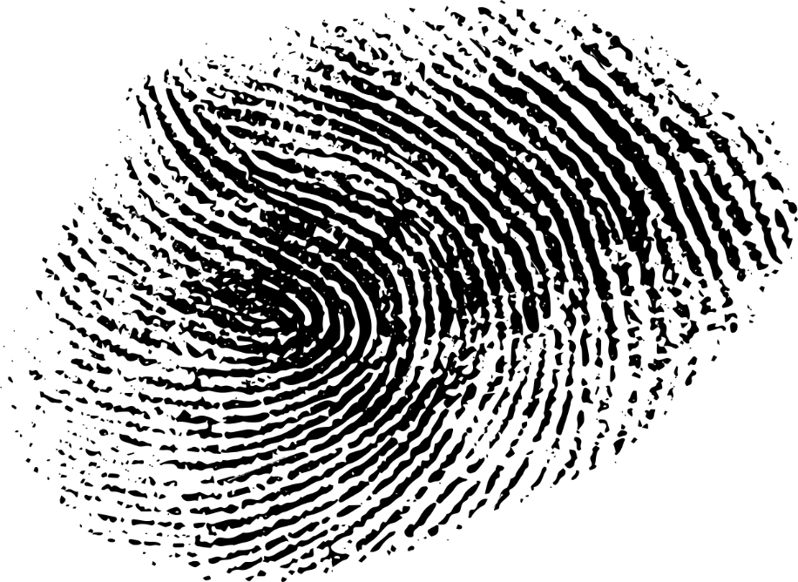
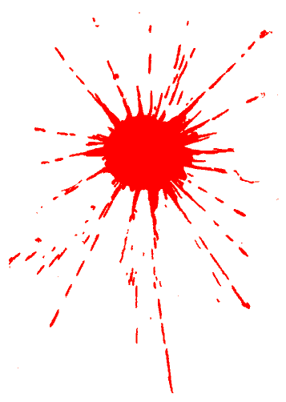

WHAT TO BRING?
Casual attire is suitable. Pen, papers, highlighter, note cards for note taking. A laptop computer is recommended but not required.

WHO SHOULD ATTEND?
This course is designed to assist in
the preparation for the IAI Crime Scene Investigator Certification: CCSI, CCSA and CSCSA examination. It would be beneficial to Crime Scene Investigators, Detectives, Officers, and anyone else wishing to seek IAI Certification, whether or not they plan to take the exam during this class week.

Hampton Inn & Suites
7050 Plantation Road
Pensacola, FL 32504
(850) 505-7500| Reserve
Reserve

RECOMMENDED LODGING
Tru by Hilton
7100 N Davis Highway
Pensacola, FL 32504
(850) 208-0100 | Reserve Reserve

MEET YOUR INSTRUCTOR
Dr. Michael Berkland, D.O.
A highly experienced forensic pathologist with over 30 years in the field, holding triple board certifications in Anatomic, Clinical, and Forensic Pathology. Trained in the U.S. Army, he has served as a Chief and Deputy Chief Medical Examiner in various locations and was previously certified as a Senior Crime Scene Analyst with the IAI.
Dr. Berkland has examined over 3,000 crime scenes and specializes in forensic subspecialties like shooting reconstruction and child fatalities. His instruction reflects the legacy Jan wanted and offers comprehensive learning experience, integrating crime scene analysis with courtroom insights, tailored for professionals in the field.
For his full biography, please visit our “Meet Your Instructors” section of our webpage at www.forensicpieces.com.

COURSE DESCRIPTION
This 28-hour course is designed to help students pass their desired level of crime scene certification exams. It offers a fast-paced review of two or three books, with numerous pre-testing exams to identify strengths and weaknesses. Suitable for both novices and experienced individuals, this course enhances your chances of certification and professionalism. Note that the tuition fee covers only the course, while exam and application fees are handled with the IAI.
The International Association for Identification Crime Scene Certification Board will arrange for a proctor on the last day of class for students to take the exam. Ensure your application is submitted and approved by the IAI at least 30 days before the exam. THIS IS A BOOK REVIEW. Check the application requirements online: www.theiai.org/crime_scene.php.
- Practical Crime Scene Processing and Investigation, 3rd edition, Ross M. Gardner, 2019, CRC Press. CCSI & CCSA
- Crime Scene Photography, 3rd Edition, by Edward Robinson, 2016, Academic Press Elsevier, Inc. (All chapters and glossary EXCLUDING chapter 8, subchapters 9.4, 9.6, 9.7, and chapters 10 and 11). CCSI & CCSA
- Practical Analysis and Reconstruction of Shooting Incidents, Second Edition, Edward E. Hueske, 2021, CRC Press (All Chapters & Glossary EXCLUDING 2, 14, 18, and 20). CCSA
- Crime Scene Photography, 3rd Edition, by Edward Robinson, 2016, Academic Press-Elsevier, Inc. (All Chapters EXCEPT 1, Subchapters 9.4, 9.6 and 9.7, and Pages 712-735). CSCSA
- Effective Expert Witnessing: Practices for the 21st Century, 5th ed. By Matson, Jack V., 2013, CRC Press (All chapters EXCEPT 8 and 9). CSCSA
- Forensic Science: An Introduction to Scientific and Investigative Techniques, 4th edition by James, Stuart H., Nordby, Jon J., and Bell, Suzanne, 2013, CRC Press. CSCSA
COURSE TOPICS: Equipment Needs, Crime Scene Safety, Scene Security, Photography, Search Techniques, Note Taking, General Documentation of Physical Evidence, Sketching Measurements, Biological Evidence Detection & Collection, Trace Evidence, Latent Impression Evidence, Shoe & Tire Track Evidence, Tool Mark Evidence, Firearms Evidence, Proper Evidence Packaging Techniques, Report Writing, Courtroom Testimony.
Basically, covers questions from nearly every chapter in each book to be studied.

